Our Lady of Peace School
OLP Parent Newsletter

2021-2022 School Year
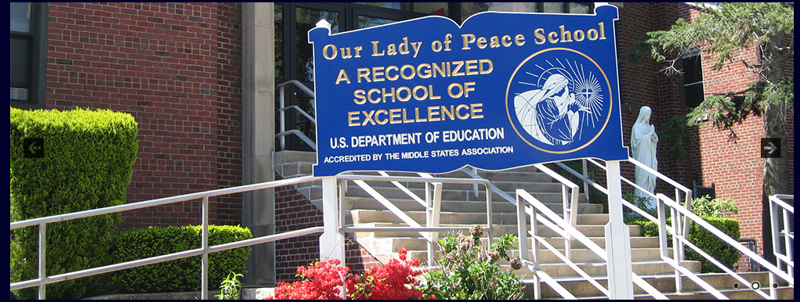
"Do Small Things With Great Love"
May 22, 2022,
Sixth Sunday of Easter

MONDAY, MAY 23, 2022
Hot Dog Lunch (K-8)
Spring Concert
Dress Rehearsal and Morning Performance 9:45 am
The beginner and advanced bands, violins, select choir, and the 8th-grade students are involved in both our performances.
***Our Ukulele students will only be performing during the morning concert.
All students should wear their FULL UNIFORM, no sweaters or sneakers.
The summer uniform is acceptable.
Evening Performance 7:00pm
GIRLS - Black dress slacks and a white shirt. (No leggings or tight-fitted pants)
BOYS - Black or blue dress pants, a white shirt and tie.
Students should arrive by 6:30pm and enter through the schoolyard doors.
Parents and guests, please enter through the door between the school and the rectory. These doors will open at 6:45pm.

TUESDAY, MAY 24, 2022
Brown Bag It (K-8)
4th Grade NYS ELA Field Test
**CHROMEBOOK MUST BE CHARGED TO 100%

WEDNESDAY, MAY 25, 2022
Pasta Lunch (K-8)
NO BROWN BAG IT
Instrument Drop Off 8:00am -Gym

THURSDAY, MAY 26, 2022
ASCENSION THURSDAY
Mass at 9:00am
Full School Uniform K-8
No NUT Cards may be used today
Summer Uniforms acceptable
Pizza Lunch (K-8)
NO BROWN BAG IT

FRIDAY, MAY 27, 2022
School Closed-Optional Snow Day
Enjoy the long weekend
VOLUNTEERS NEEDED
The Parent’s Association needs volunteers for the
8th Grade Graduation
Below is the link for the sign-up genius
https://www.signupgenius.com/go/4090A48A5A72DA6F94-olp

MAY CROWNING
“O Mary, we crown thee with blossoms today!
Queen of the Angels and Queen of the May.
O Mary, we crown thee with blossoms today,
Queen of the Angels and Queen of the May.”
Thank you to our 2nd and 7th graders who participated in our beautiful
May Crowning Ceremony!
Thank you to all the parents and parishioners who could join us on this special day!
Our Lady of Peace, pray for us!
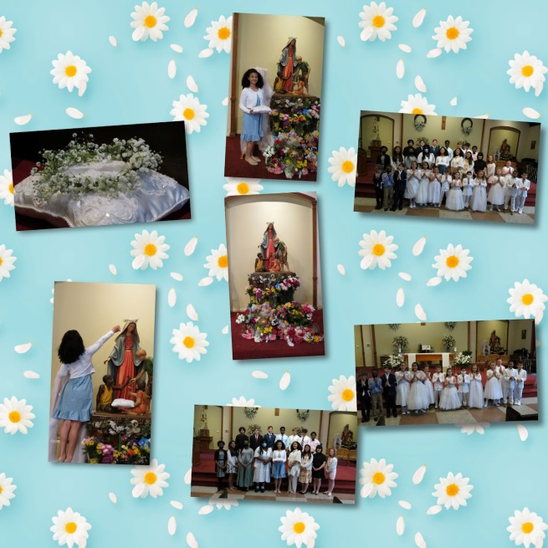
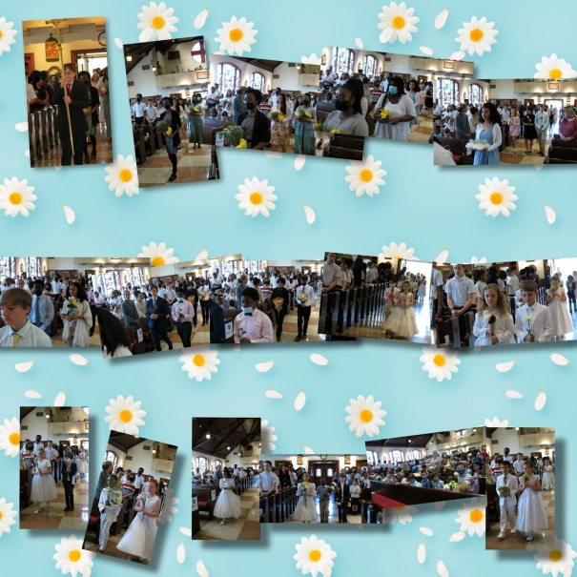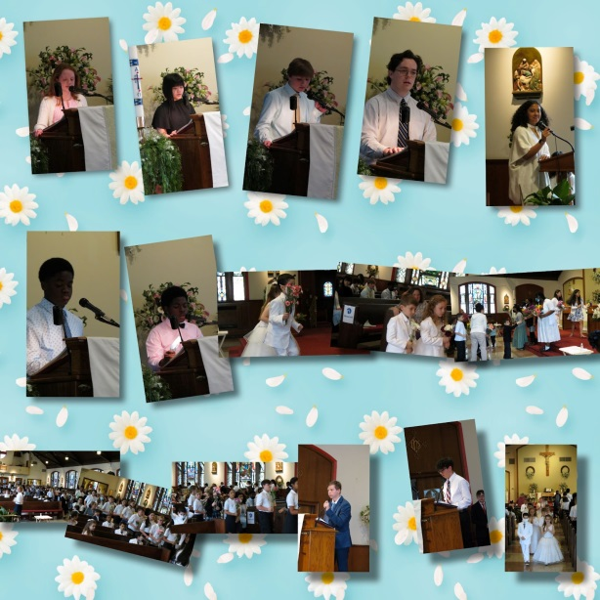\

ENRICHMENT CLASS MOCK TRIAL
Congratulations to our Enrichment Class that participated in the
Catholic Middle Schools Mock Trial, held at John’s University School of Law.
Our “Prosecution Team” did an outstanding job! We are so proud of you!
A SPECIAL “THANK YOU” to Mrs. Battista for all her time, dedication, and hard work to prepare our Enrichment Class for this wonderful experience.
Thank you to all who attended the Mock Trial and supported our Enrichment Class!
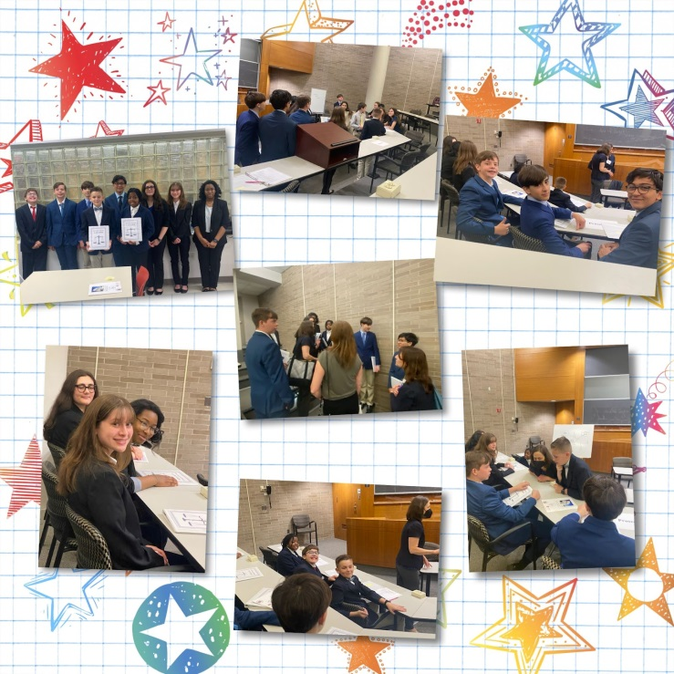

OLP PRINCESS BALL
Special Thank You to Mrs. Simon and all who helped to make our Princess Ball a success.
Fathers and Daughters had a great time.

SPEECH CONTEST FINALS
Verbal or Non-Verbal Communication: Which is More Powerful?
This was the topic of our Middle School Speech Finals.
All of our finalists did an outstanding job presenting their topics.
Congratulations to 2nd place Lacey & Nicolette and 1st place Shia.
A special thank you to our judges, Mrs. Wong, Mrs. Fitzmartin & Mrs. Bradley, all volunteers from Sr. Barbara’s Parish Social Ministry.
Congratulations, we are very proud of you!

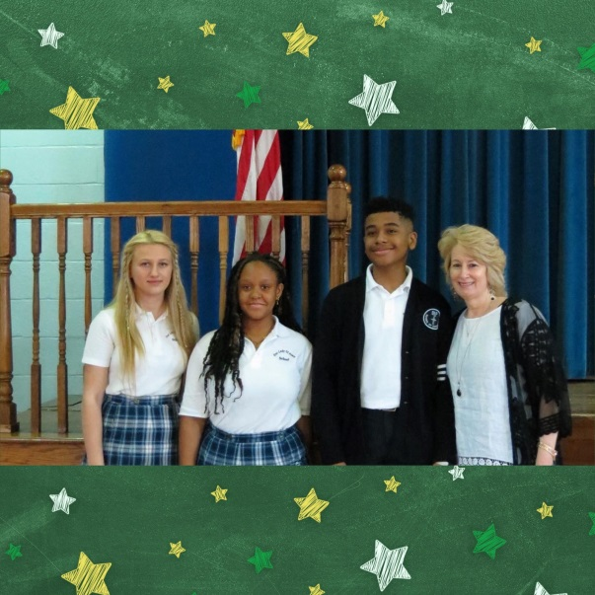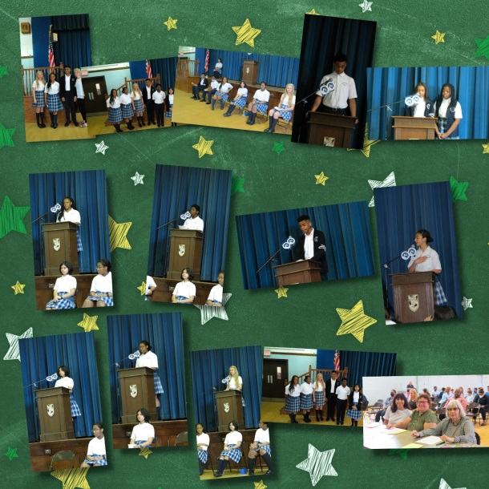
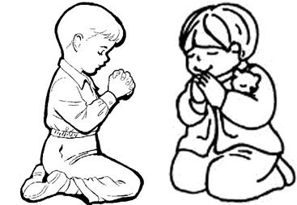
Shoe Boxes for the Children of Ukraine
In conjunction with Sr. Barbara and the OLP Parish Social Ministry, Our Lady of Peace School will participate in “Shoe Boxes for the Children of Ukraine.”
By wrapping an ordinary shoebox filled with toys and other presents, you have just made an extraordinary gift for a child who needs joy and hope.

How to pack your shoebox gift:
Use an empty shoebox, wrap the box and wrap the lid separately.
Indicate whether your gift will be for a boy or a girl and the age.
Make a label with this information and tape it to the top of your box.
Place a prayer in the box.
Fill the box with some of the gifts from the list below.
Place a rubber band around the shoebox and bring it to school by Thursday, June 16, 2020.

Suggested Items:
Toys: Small cars; dolls; stuffed animals; yo-yos; card games; jump ropes; slinky; small Etch A Sketch; puppets
School Supplies: Pens; pencils; crayons; markers; stamps and ink pad sets; small manual sharpeners; coloring books; picture books; writing pads or paper; stickers, glue sticks

Other: Socks; sunglasses; flashlights; baseball caps.

Please do not include the following: used or damaged items, war-related items, chocolate or food, liquids or lotions, medications, vitamins, breakable items, and aerosol cans.
Thank you for your prayers, concern, and support for the people of Ukraine.
YEARBOOK ORDER FORM
It is not only for the graduates but also for students of all
ages. Parents, grandparents, relatives, and friends will
enjoy flipping through the colorful pages jam-packed with
precious photos and priceless memories of all of the
students and their teachers at OLP.
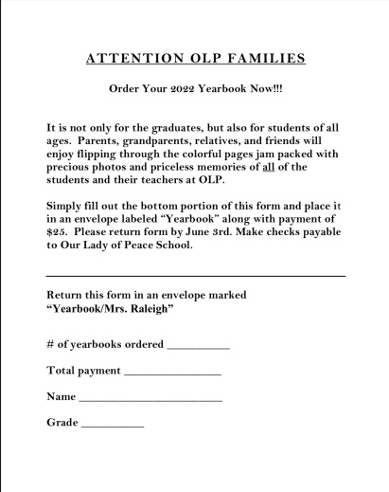
CLICK HERE FOR THE YEARBOOK ORDER FORM
OLP CAR MAGNETS
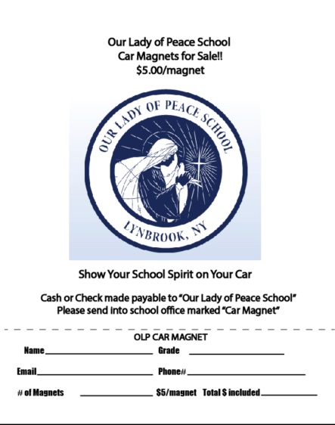
CLICK HERE FOR CAR MAGNET ORDER FORM

2022-2023 REGISTRATION
Re-registration forms were sent home in your child’s backpack.
Please complete and return ASAP.

STORE GIFT CERTIFICATE PROGRAM
Every school family in grades K-8 must participate in our school’s Script Program and purchase a minimum of $2000.00 in gift cards per family.
To make this program more convenient for our families, in addition to selling gift cards at the school, we have implemented the
“Raise Right Program”
You can purchase gift cards from
750+ brands right from an app on your phone.
This is a convenient and easy way to complete your gift certificate obligation.
RAISE RIGHT FLYER
RAISE RIGHT START-UP INSTRUCTIONS
RAISE RIGHT TUTORIAL VIDEO

TOMORROW’S HOPE APPLICATION
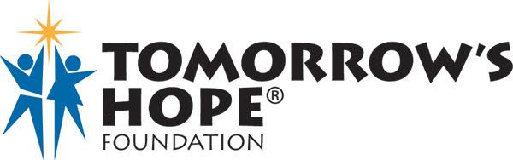

Please apply early as awards are based on a first come, first-serve basis.
Tomorrow's Hope applications for the 2022-23 school year
are now available online.
As of January 20, 2022, you may access the application by clicking on the link below:
https://online.factsmgt.com/grant-aid/inst/4KYQC/landing-page

SCHOOL UNIFORM POLICY
We will be making efforts to remind our OLP students of our expectations for our school community.
Due to the COVID restrictions over the past two years, we have not emphasized some of our expectations, such as properly wearing the Our Lady of Peace School uniform. Over the past two years, we have relaxed the school uniform rules to deal with the stress of the pandemic. As we move forward, we will work on properly wearing the school uniform as a school community.

For your convenience, the descriptions of the school uniforms are below.

DRESS AND APPEARANCE
All students are expected to have a neat, clean, well-groomed appearance. The school reserves the right to reject unsuitable modes of appearance and remove a student from class if they are not in uniform. It is the parents' responsibility to correct any of the following problems. Students will receive a demerit after one warning is given.

Uniforms
Girl's skirts must touch the top of the knee.
Uniform socks must be worn. No "trendy" sports socks are permitted.
Socks must cover the ankles.
Boys must wear the school sweaters from October 15th – to May 1st.

Hair
Current fads in hairstyles are not acceptable for girls or boys.
The length of the boy's hair must be above the top of his collar.
Hair must be its natural color and cannot be dyed.

Make-up
The wearing of any make-up is NOT permitted.
If make-up is worn, the student will be asked to remove it.

Jewelry
Wearing "trendy" jewelry and multiple bracelets are not acceptable.
Girls may not wear dangling earrings, large hoops, multiple earrings, or earrings above the lower lobe.
Boys may not wear earrings.
Any other body piercing by both girls and/or boys is not permitted
Nail Polish must be limited to clear or light pink.

SUMMER UNIFORM (Optional)
Can be worn from September 8th– October 15th, May 2nd– June 22nd
Navy Uniform Skort (GIRLS) or Walking Shorts (BOYS and GIRLS)
White Three-buttoned shirt with school name
Grades 6, 7, and 8 may wear the Three-buttoned Shirt with Uniform Slacks, Skirt, Shorts, or Skort.
Solid White or Navy Crew Socks
Uniform Shoes are required.

PHYSICAL EDUCATION UNIFORM
Grades K-8
All students must wear shorts to participate in physical education.
Blue School T-Shirt and Blue Gym Shorts (must be purchased from Flynn & O'Hara)
are to be worn to school on Gym days instead of the school uniform.
OLP Gym Uniform sweatshirts & sweatpants may be worn over the gym uniform in the winter.
Lace-up or Velcro Sneakers should be worn to school on gym days instead of school shoes.
September 8th, October 15th, May 2nd – June 22nd, the summer uniform can be worn for Physical Education.

UPDATE COVID PROTOCOLS

- As of March 2, 2022, wearing face masks indoors, outdoors, and on school buses for students, faculty, and staff is optional.

- Students will no longer be required to leave the school setting if they are deemed COVID-19 “close contact.”

- A “close contact” is a person, regardless of vaccination status, who was less
than 6 feet away from an infected person for a cumulative total of 15 minutes or more over the 24-hour period (for example, three individual 5-minute exposures for a total of 15 minutes).

- If a student is deemed a “close contact” it is recommended that the student wear a well-fitted medical grade face mask starting the day after exposure through day ten (10).

- It is recommended that students test on day five (5) and send a picture of the result to Ms. Von Braunsberg and Mrs. Livreri.

- Home testing kits can be used for students who are deemed “close contacts”
and display no symptoms.

- Please contact Ms. Von Braunsberg if you need home testing kits.

- “General Proximate Contact” notices will continue to be emailed to classes if a positive case should occur.

- Close contacts will be notified by a phone call and email notification.

- If a student tests positive for COVID-19 they are required to isolate for five (5) days regardless of vaccination status. When they return to school they are REQUIRED to wear a well-fitted medical grade face mask for days six (6) through ten (10).

- No student is permitted to be in the school building while the results of their COVID-19 test are pending.

- If your child is fully vaccinated, please send Ms. Von Braunsberg a copy of your child's vaccination card.

- Regardless of vaccination status, all students must stay home from school if they are experiencing any COVID-19 signs or symptoms of illness.

- If your child is showing symptoms, even if you think it might not be COVID-19, or if any member of your household becomes symptomatic or tests positive for COVID, please call Our Lady of Peace School.

- Weekly testing of unvaccinated faculty, staff, and parent volunteers will continue.

OLP'S FOOD PANTRY
As part of our school's Mission Statement
"educate the whole child in the spirit of service and compassion."
We support OLP's Parish Social Ministry's Food Pantry.
Each month two grades are asked to donate food for the Food Pantry.
For the month of MAY, the 6th & 2nd grades are asked to donate food for the pantry.

DIVERSITY AND EQUALITY
At Our Lady of Peace School, the work of diversity, equality, and inclusion is the responsibility of the pastor, administration, faculty, staff, students, their families, and our entire school and parish family. We recognize that Our Lady of Peace School exists in an ever-changing world and that our understanding of and support for diversity, equality, and inclusion must grow and evolve. We will not tolerate anything less. We all have a role in ensuring every child at Our Lady of Peace School continues to feel known, valued, and loved.
Our daily morning prayers will include our
"Diversity and Equality Prayer."
At Our Lady of Peace School, we will continue to live by our Mission.

"Rooted in the tradition of the Sisters of Mercy, we at Our Lady of Peace School are called to educate the whole child in the spirit of service and compassion. We strive as a community, coupled with God's love, to inspire each child to grow spiritually and academically in a diverse and increasingly challenging world."
John 13:34
"A new commandment I give to you, that you love one another, even as I have loved you, that you also love one another."

BROWN BAG IT LUNCH
Brown Bag-it Gourmet Catering (brownbagitgourmetcatering.com)

PARKING
Please DO NOT park in the shopping center parking lot across from the school.
Those parking spots are for the patrons of the stores.
Small businesses are struggling, and if school parents take the spots, that could potentially take business away from the stores.
Please DO NOT block the driveways of our school neighbors.
Please DO NOT double park. You are putting the safety of our students in jeopardy.
Thank you.

DISMISSAL
PLEASE DO NOT PARK ON NEIMAN AVENUE WHEN THE CONES ARE PLACED ALONG THE SCHOOLYARD FENCE.
PLEASE DO NOT BLOCK OUR NEIGHBOR’S DRIVEWAYS.

"Do Small Things With Great Love"
Stay safe, and God bless,
Ms. Karen Von Braunsberg
Principal
Our Lady of Peace School
21 Fowler Avenue
Lynbrook NY 11563

Mission Statement
“Rooted in the tradition of the Sisters of Mercy, we at Our Lady of Peace School are called to educate the whole child in the spirit of service and compassion. We strive as a community coupled with God’s love, to inspire each child to grow spiritually and academically in a diverse and challenging world.”

